Facilities
Sacred Hearts Nursery School was established in 1966 by the Sisters of the Little Workers of the Sacred Hearts of Jesus and Mary and is operated and directed by the same community.
Philosophy
The Sisters of the Little Workers of the Sacred Hearts of Jesus and Mary operate and direct Sacred Hearts Nursery School as an integral part of their Catholic education program and also as a service to the general community regardless of race, nationality, sex, or creed. The Sisters strive to provide quality care and learning opportunities for children in an atmosphere where Catholic values and love are evident. The Sisters thereby affirm their total commitment to the good of young children and to the advancement and harmony in family life.
Facilities
We have ample supplies of educational equipment, large work areas, and an enclosed outdoor playground area with safe recreational equipment.
Program
The Sisters provide a program and environment that promotes the spiritual, educational, emotional, and physical development of the children. The policy is to prepare, in every possible way, children from the ages of three to five for their future years. The program is planned to make young children feel loved, secure and self-confident.

Children say basic prayers and sing common hymns. They learn to interact with other children their own age and to pursue their interests in the following:
Creative Arts
Nap Time
Nursery Rhymes Dramatizations
Oral Expression
Block Building
Spelling
Lunch Time
Outdoor Playground Activities
Snack Time
Fine and Gross Motor Activities
Numbers
Books, Stories, Listening

With these carefully chosen materials and activities,
the children can develop and make progress.
They can discover and explore the world around them
while under constant supervision and guidance of ou staff
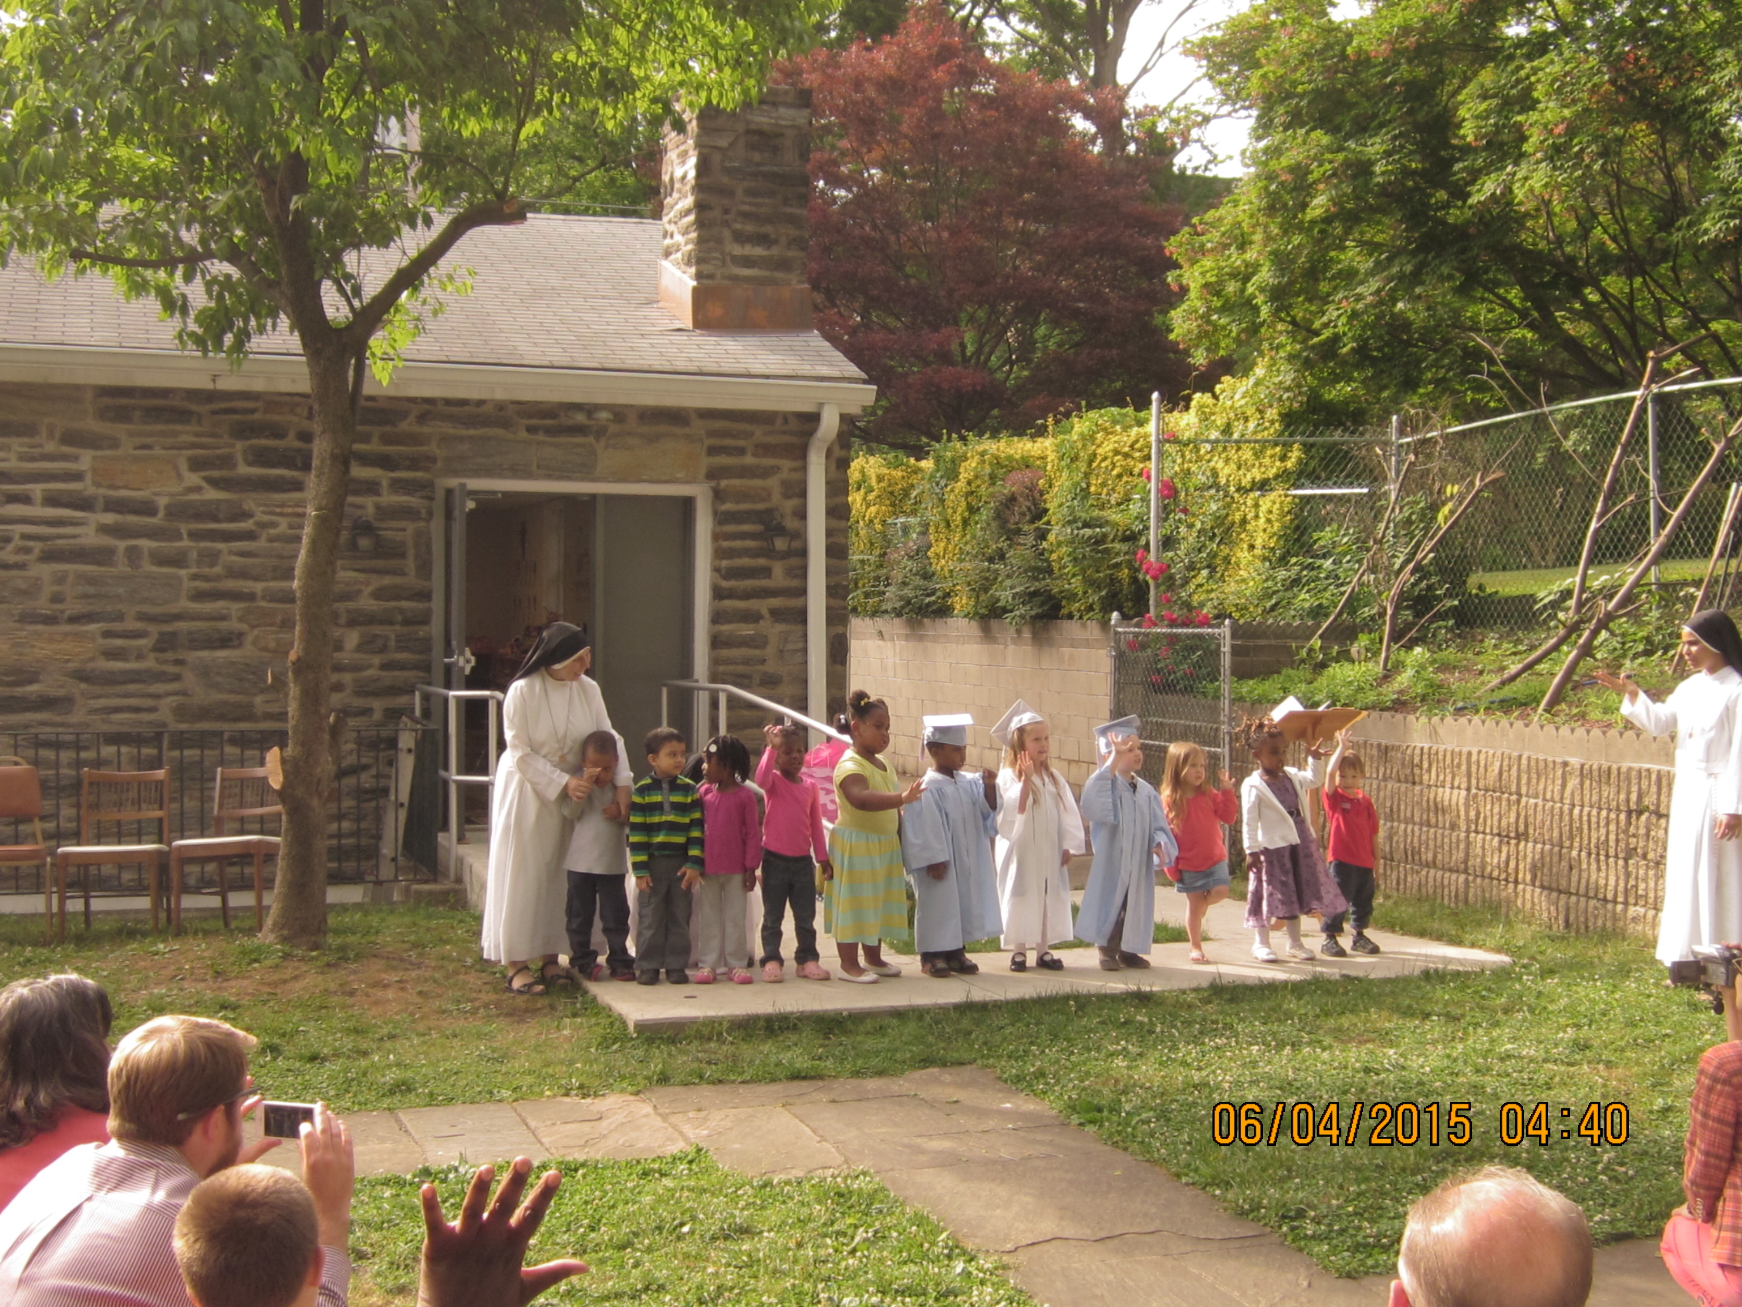
GRADUATION

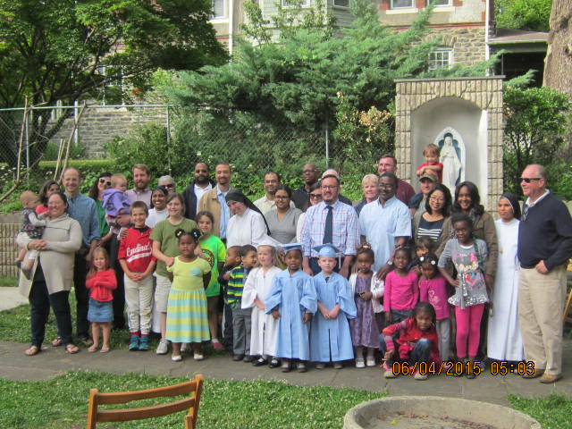

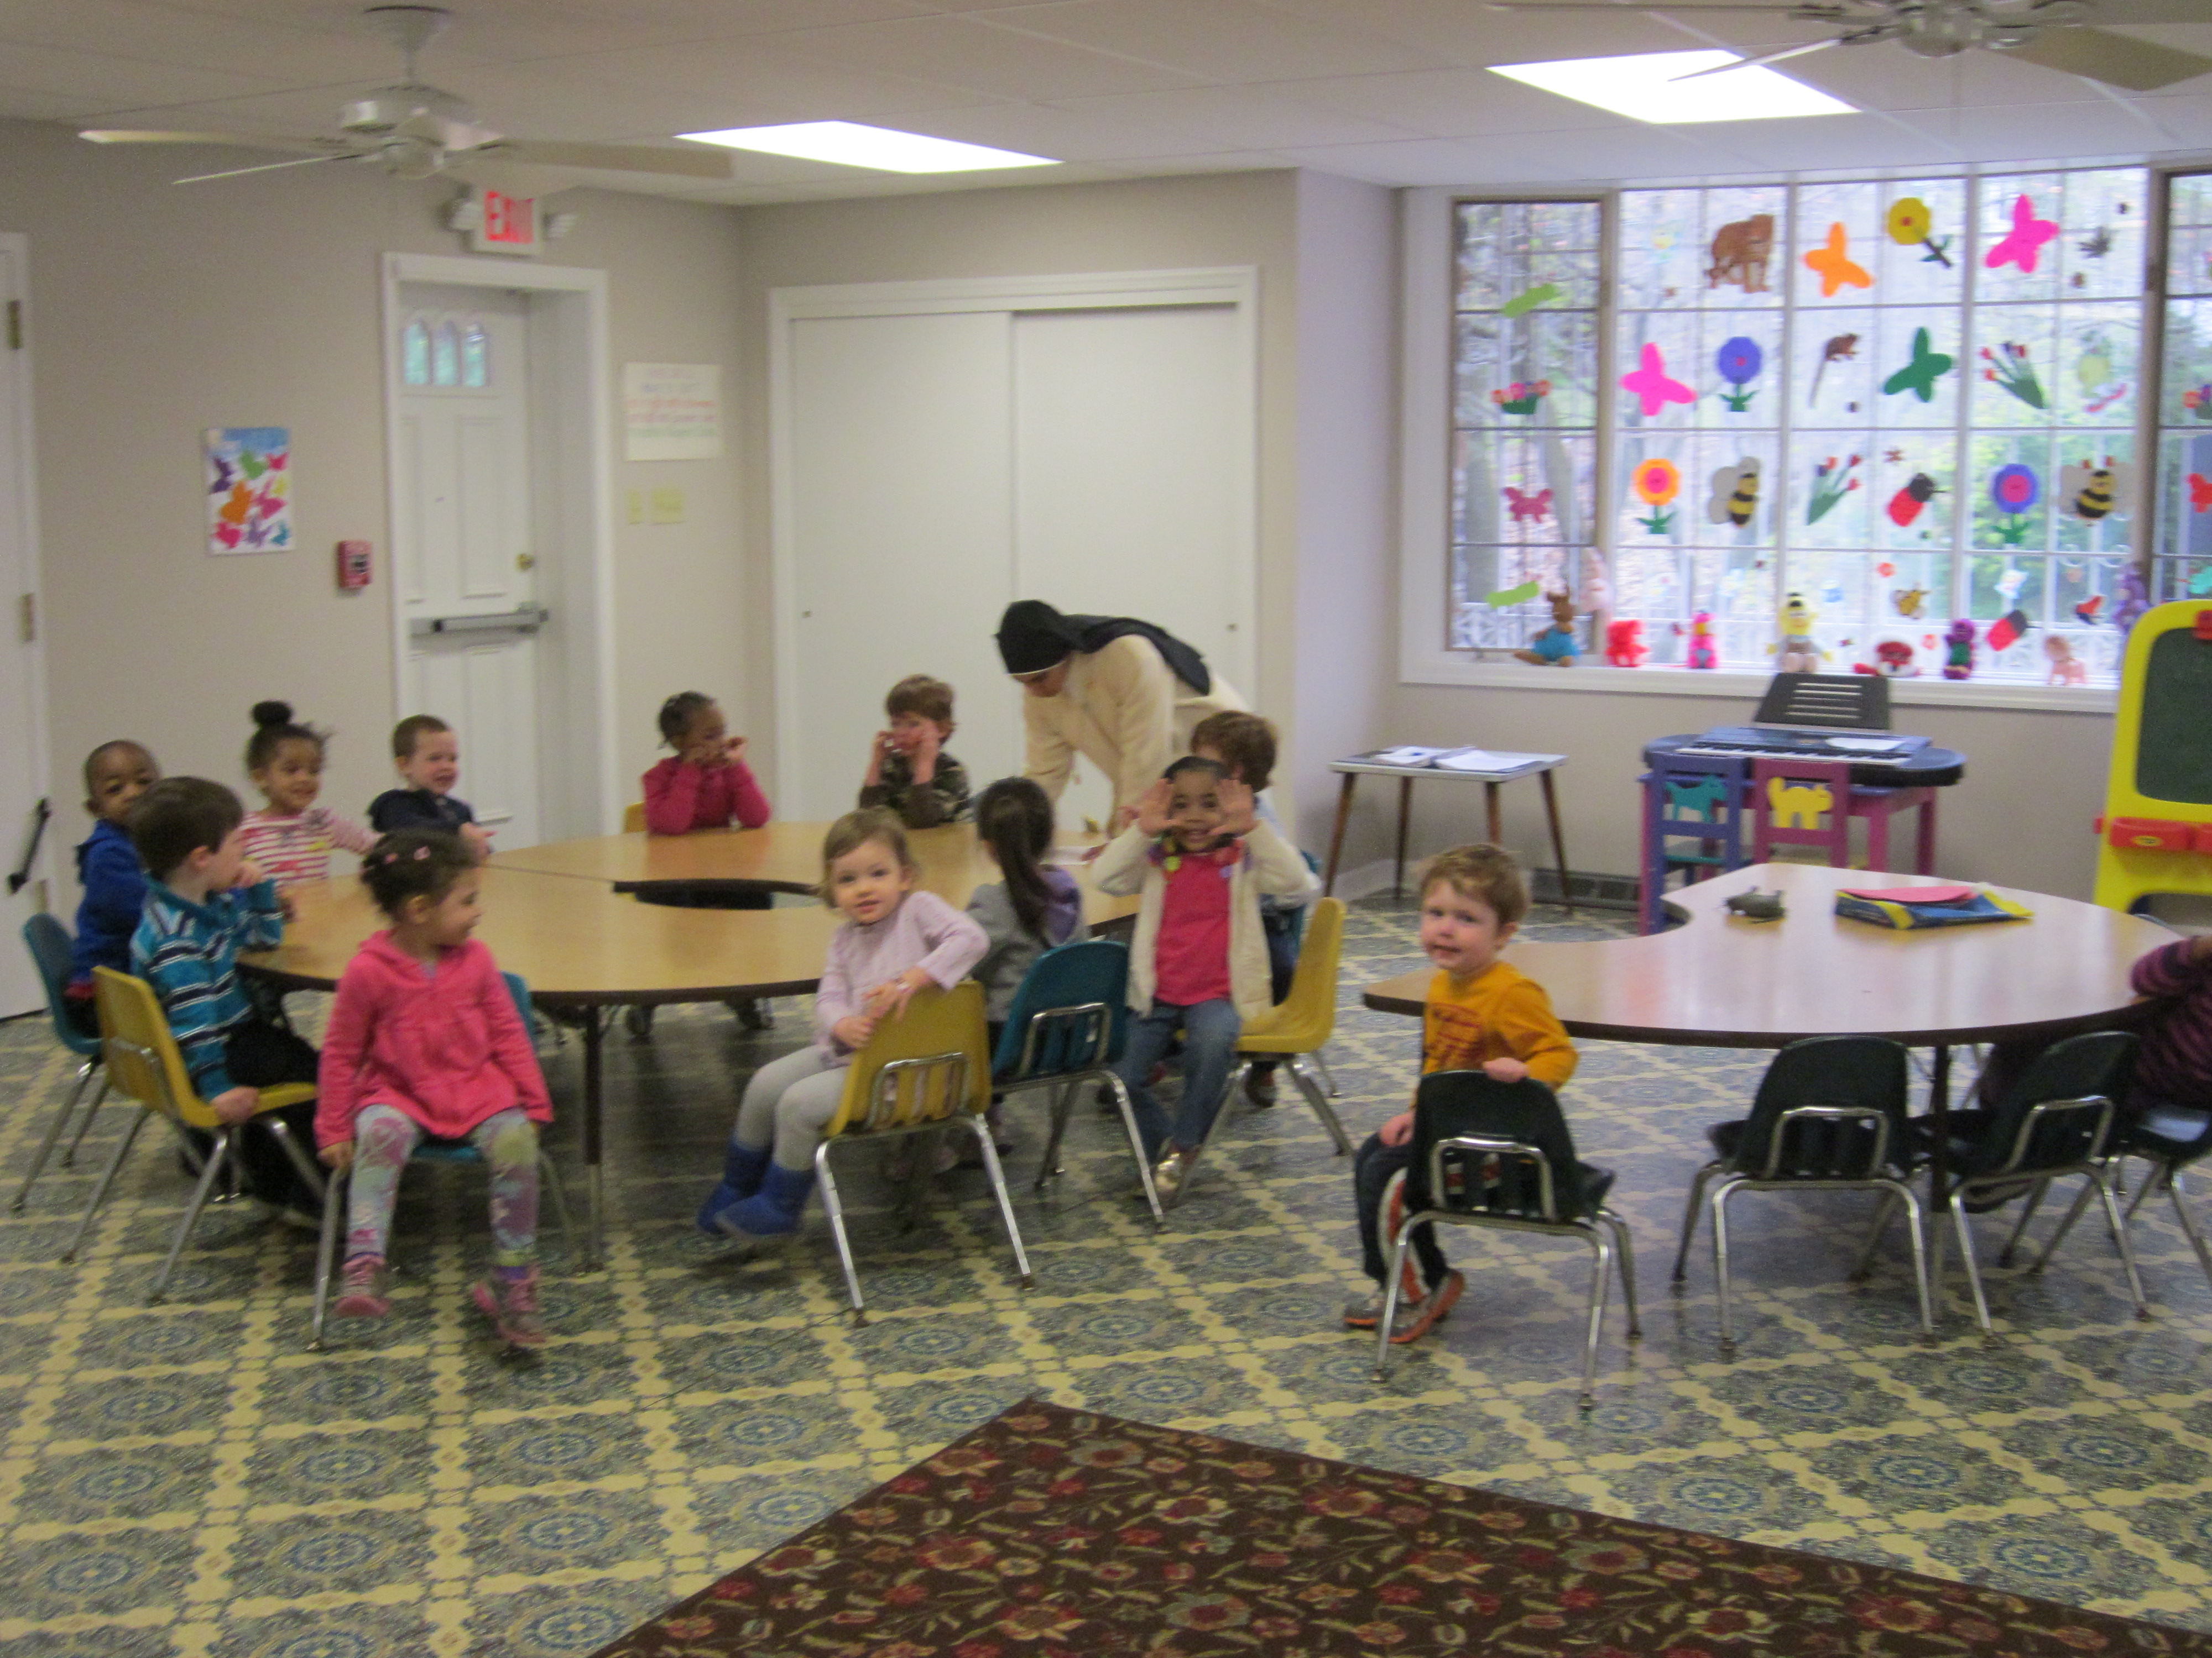
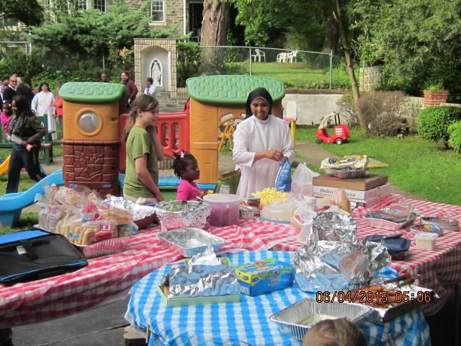

Sacred Hearts Nursery School operates on a year-round
basis, Monday to Friday, 7:30 a.m. to 5 p.m. A vacation
time of two weeks is observed.
Eligibility
All toilet-trained children in goo d health who will be
three years of age regardless of race, nationality, sex
or creed, are eligible for acceptance to our institution.
Registration
Registration forms are available at the office. At the
time of registration a medical form will be given to the parent for the child. Your physician, upon giving the child a medical examination, will complete this medical form and return it to our office as soon as
possible.
Tuition
The weekly tuition fees are based on a five-day program
for three-year old's; a five-day program for four-year old's;
and a five-day program for five-year old's. Please inquire at the office regarding the exact amount of tuition fees.
Tuition fees are payable at the end of each week.

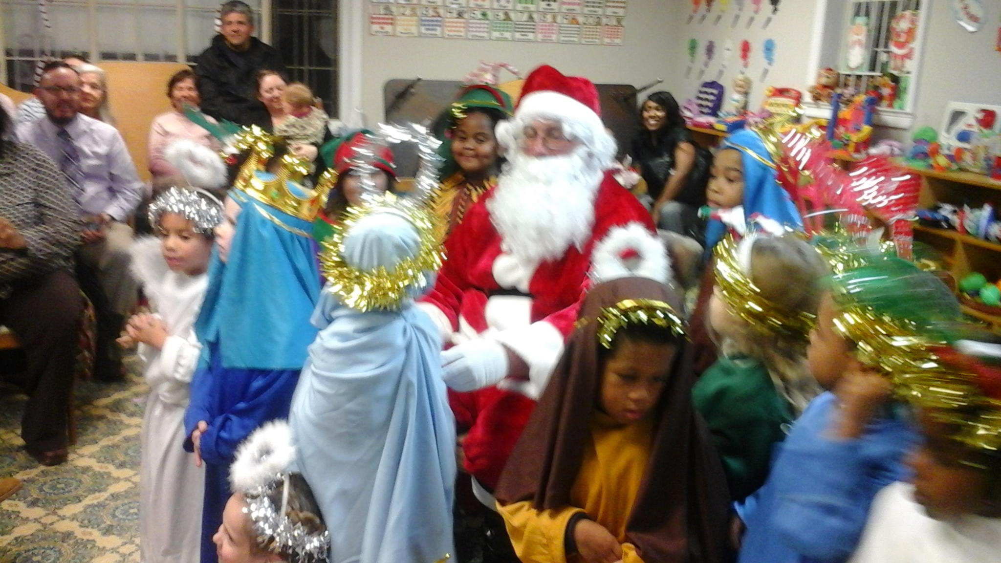

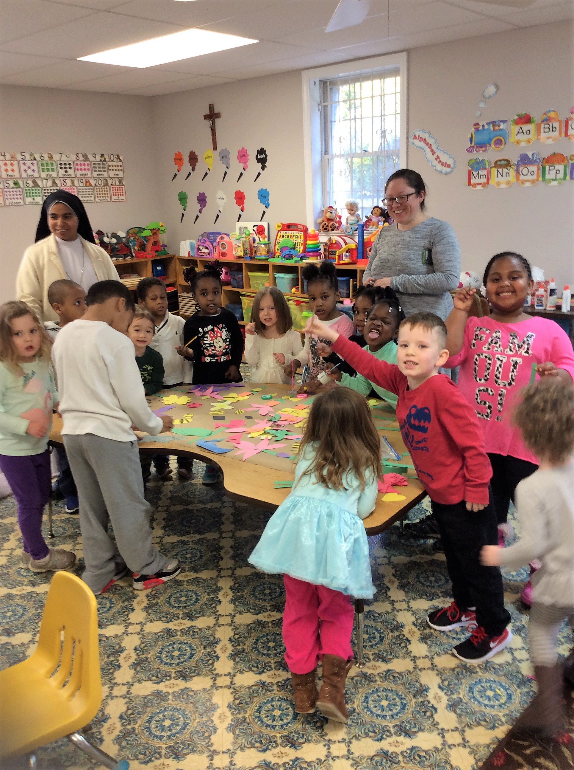

Sacred Hearts
Pre School
160 W. Carpenter Lane
Philadelphia, PA 19119-2563
215-843-2266

